UNIT – V
- EXPLAIN THE TRANSACTION PROPERTIES IN DETAILS WITH EXAMPLE ( APR 2011)
- A transaction is a unit of program execution that accesses and possibly updates various data items.
- Usually, a transaction is initiated by a user program written in a High-level data-manipulation language or programming language, where it is delimited by statements (or function calls) of the form begin transaction and end transaction.
- A transaction may not always complete its execution successfully. Such a transaction is termed aborted.
- Any changes that the aborted transaction made to the database must be undone. Once the changes caused by an aborted transaction have been undone, we say that the transaction has been rolled back.
- A transaction that completes its execution successfully is said to be committed. A committed transaction that has performed updates transforms the database into a new consistent state, which must persist even if there is a system failure.
- The only way to undo the effects of a committed transaction is to execute a compensating transaction. A transaction must be in one of the following states:
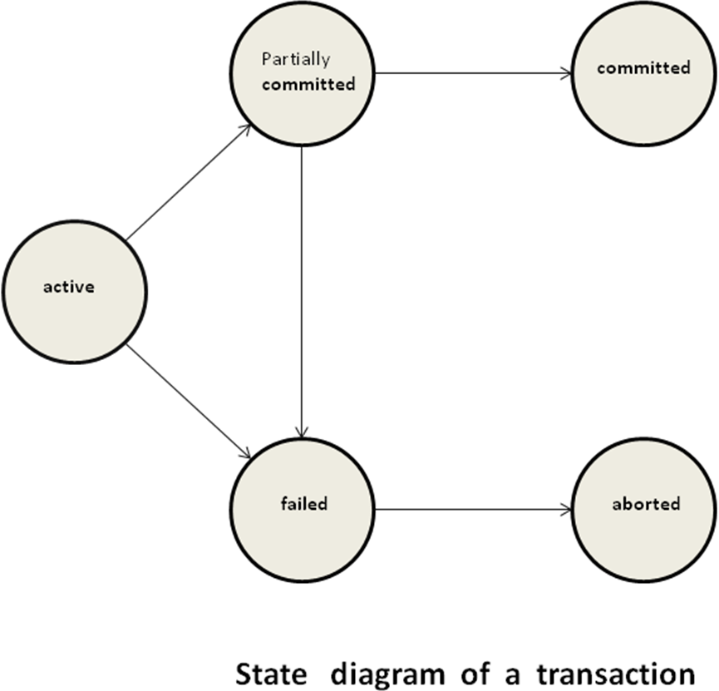

- Active, the initial state; the transaction stays in this state while it is executing.
- Partially committed, after the final statement has been execute.
- Failed, after the discovery that normal execution can no longer Proceed.
- Aborted, after the transaction has been rolled back and the database has been restored to its state prior to the start of the transaction.
- Committed, after successful completion.

- To ensure integrity of the data, we require that the database system maintain the following properties of the transactions:
- Atomicity. Either all operations of the transaction are reflected properly in the database, or none are.
- Consistency. Execution of a transaction in isolation (that is, with no other transaction executing concurrently) preserves the consistency of the database.
- Isolation. Even though multiple transactions may execute concurrently, the system guarantees that, for every pair of transactions Ti and Tj, it appears to Ti that either Tj finished execution before Ti started, or Tj started execution after Ti finished. Thus, each transaction is unaware of other transactions executing concurrently in the system.
- Durability. After a transaction completes successfully, the changes it has made to the database persist, even if there are system failures.
- These properties are often called the ACID properties; the acronym is derived from the first letter of each of the four properties
- Transactions access data using two operations:
  - read(X), which transfers the data item X from the database to a local buffer belonging to the transaction that executed the read operation.
  - write(X), which transfers the data item X from the local buffer of the transaction that executed the write back to the database.
- Let Ti be a transaction that transfers $50 from account A to account B. This transaction can be defined as
- Transaction to transfer $50 from account A to account B:
1. read(A)
2. A := A – 50
3. write(A)
4. read(B)
5. B := B + 50
6. write(B)
- Let us now consider each of the ACID requirements.
Consistency: The consistency requirement here is that the sum of A and B be unchanged by the execution of the transaction. If the database is consistent before an execution of the transaction, the database remains consistent after the execution of the transaction.
Atomicity: Suppose that, just before the execution of transaction Ti the values of accounts A and B are $1000 and $2000, respectively. Suppose that the failure happened after the write (A) operation but before the write (B) operation. In this case, the values of accounts A and B reflected in the database are $950 and $2000. The system destroyed $50 as a result of this failure. We term such a state an inconsistent state. If the atomicity property is present, all actions of the transaction are reflected in the database, or none are. Ensuring atomicity is the responsibility of the database system itself; specifically, it is handled by a component called the transaction-management component.
Durability: The durability property guarantees that, once a transaction completes successfully, all the updates that it carried out on the database persist, even if there is a system failure after the transaction completes execution. We can guarantee durability by ensuring that either
- The updates carried out by the transaction have been written to disk before the transaction completes.
- Information about the updates carried out by the transaction and written to disk is sufficient to enable the database to reconstruct the update when the database system is restarted after the failure.
Ensuring durability is the responsibility of a component of the database system called the recovery-management component.

Isolation:
Even if the consistency and atomicity properties are ensured for each transaction, if several transactions are executed concurrently, their operations may interleave in some undesirable way, resulting in an inconsistent state. A way to avoid the problem of concurrently executing transactions is to execute transactions serially—that is, one after the other. Ensuring the isolation property is the responsibility of a component of the database system called the concurrency-control component executes transactions serially—that is, one after the other.

Implementation of Atomicity and Durability:
- The recovery-management component of a database system can support atomicity and durability by a variety of schemes.
- We first consider a simple, but extremely inefficient, scheme called the shadow copy scheme.
- This scheme, which is based on making copies of the database, called shadow copies, assumes that only one transaction is active at a time.
- A pointer called db-pointer is maintained on disk; it points to the current copy of the database.
- In the shadow-copy scheme, a transaction that wants to update the database first creates a complete copy of the database.
- All updates are done on the new database copy, leaving the original copy, the shadow copy, untouched.
- If at any point the transaction has to be aborted, the system merely deletes the new copy.
- The old copy of the database has not been affected.
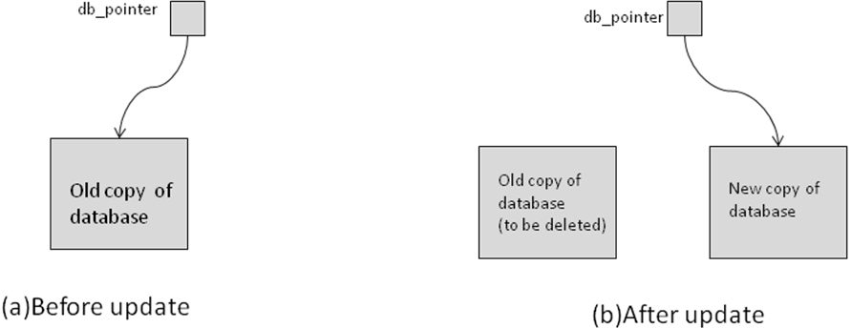
Shadow-copy technique for atomicity and durability.

- The transaction is said to have been committed at the point where the updated db-pointer is written to disk.
- If the transaction fails at any time before db-pointer is updated, the old contents of the database are not affected.
- Suppose that the system fails at any time before the updated db-pointer is written to disk.
- Then, when the system restarts, it will read db-pointer and will thus see the original contents of the database, and none of the effects of the transaction will be visible on the database.
- Next, suppose that the system fails after db-pointer has been updated on disk.
- Before the pointer is updated, all updated pages of the new copy of the database were written to disk.
- Thus, the atomicity and durability properties of transactions are ensured by the shadow-copy implementation of the recovery-management component.
Concurrent Executions:
- Transaction-processing systems usually allow multiple transactions to run concurrently.
- Allowing multiple transactions to update data concurrently causes several
complications with consistency of the data. There are two good reasons for allowing concurrency:
• Improved throughput and resource utilization. A transaction consists of many steps. Some involve I/O activity; others involve CPU activity. Therefore, I/O activity can be done in parallel with processing at the CPU. All of this increases the throughput of the system correspondingly; the processor and disk utilization also increases.
• Reduced waiting time. There may be a mix of transactions running on a system, some short and some long. Concurrent execution reduces the unpredictable delays in running transactions. Moreover, it also reduces the average response time: the average time for a transaction to be completed after it has been submitted.

- DISCUSS IN DETAIL THE SERIALIZABILITY. (NOV 2009)
SERIALIZABILITY
- Basic Assumption – Each transaction preserves database consistency.
- Thus serial execution of a set of transactions preserves database consistency.
- A (possibly concurrent) schedule is serializable if it is equivalent to a serial schedule. Different forms of schedule equivalence give rise to the notions of:
- conflict serializability
- view serializability
- Simplified view of transactions
- We ignore operations other than read and write instructions
- We assume that transactions may perform arbitrary computations on data in local buffers in between reads and writes.
- Our simplified schedules consist of only read and write instructions.
Conflicting Instructions
- Instructions l_{i} and l_{j} of transactions T_{i} and T_{j} respectively, conflict if and only if there exists some item Q accessed by both l_{i} and l_{j}, and at least one of these instructions wrote Q.
- l_{i} = read(Q), l_{j} = read(Q). l_{i} and l_{j} don’t conflict.
- l_{i} = read(Q), l_{j} = write(Q). They conflict.
- l_{i} = write(Q), l_{j} = read(Q). They conflict
- l_{i} = write(Q), l_{j} = write(Q). They conflict
- Intuitively, a conflict between l_{i} and l_{j} forces a (logical) temporal order between them.
- If l_{i} and l_{j} are consecutive in a schedule and they do not conflict, their results would remain the same even if they had been interchanged in the schedule.
Conflict Serializability
- If a schedule S can be transformed into a schedule S´ by a series of swaps of non-conflicting instructions, we say that S and S´ are conflict equivalent.
- We say that a schedule S is conflict serializable if it is conflict equivalent to a serial schedule
- Schedule 3 can be transformed into Schedule 6, a serial schedule where T₂ follows T₁, by series of swaps of non-conflicting instructions.
- Therefore Schedule 3 is conflict serializable.

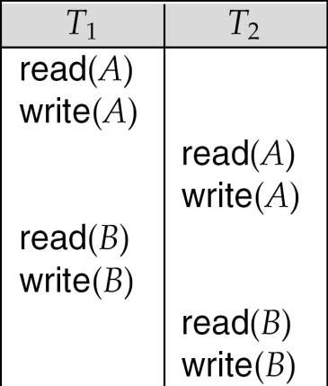
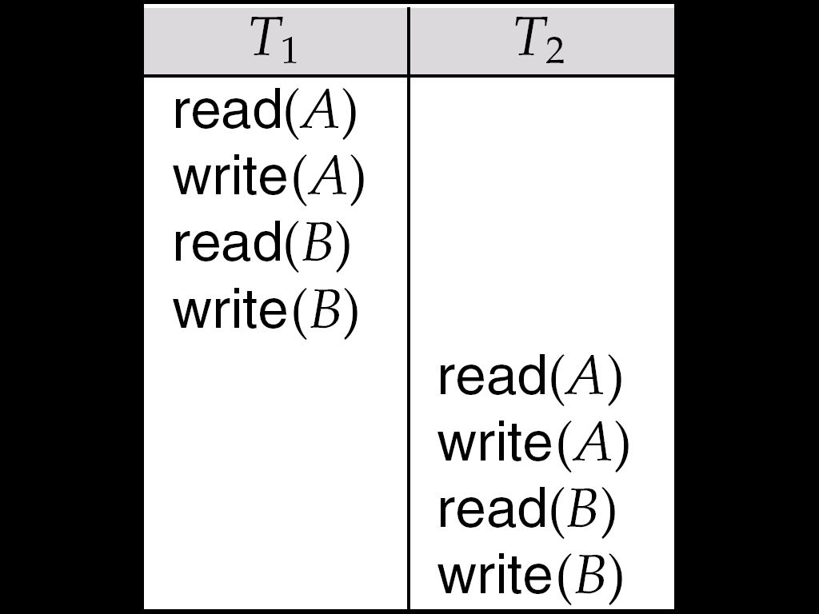
Schedule 3 Schedule 6
- Example of a schedule that is not conflict serializable:
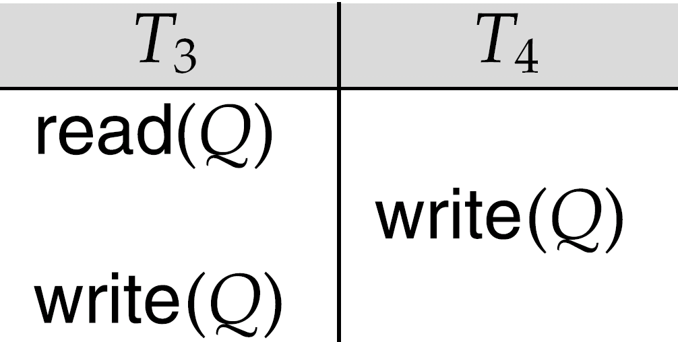
- We are unable to swap instructions in the above schedule to obtain either the serial schedule < T₃, T₄ >, or the serial schedule < T₄, T₃ >.
View Serializability
- Let S and S´ be two schedules with the same set of transactions. S and S´ are view equivalent if the following three conditions are met, for each data item Q,
- If in schedule S, transaction T_{i} reads the initial value of Q, then in schedule S’ also transaction T_{i} must read the initial value of Q.
- If in schedule S transaction T_{i} executes read(Q), and that value was produced by transaction T_{j} (if any), then in schedule S’ also transaction T_{i} must read the value of Q that was produced by the same write(Q) operation of transaction T_{j} .
- The transaction (if any) that performs the final write(Q) operation in schedule S must also perform the final write(Q) operation in schedule S’.
- As can be seen, view equivalence is also based purely on reads and writes alone.
- A schedule S is view serializable if it is view equivalent to a serial schedule.
- Every conflict serializable schedule is also view serializable.
- Below is a schedule which is view-serializable but not conflict serializable.
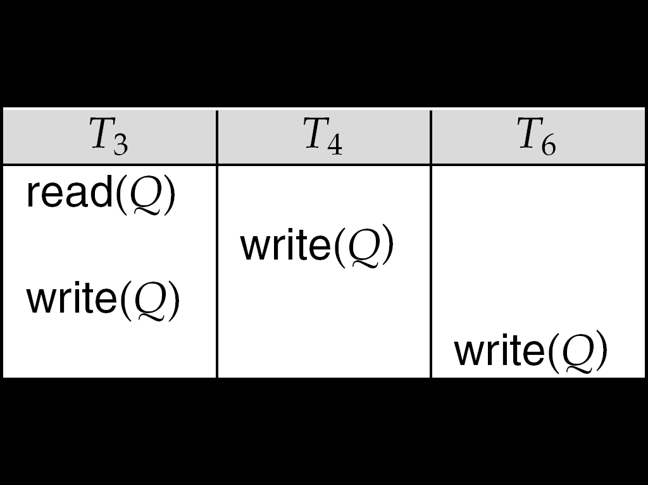
- What serial schedule is above equivalent to?
- Every view serializable schedule that is not conflict serializable has blind writes

Test for Conflict Serializability
- A schedule is conflict serializable if and only if its precedence graph is acyclic.
- Cycle-detection algorithms exist which take order n² time, where n is the number of vertices in the graph.
- Better algorithms take order n + e where e is the number of edges.
- If precedence graph is acyclic, the serializability order can be obtained by a topological sorting of the graph.
- This is a linear order consistent with the partial order of the graph.
- For example, a serializability order for Schedule A would be
- T₅ → T₁ → T₃ → T₂ → T₄
- Are there others?

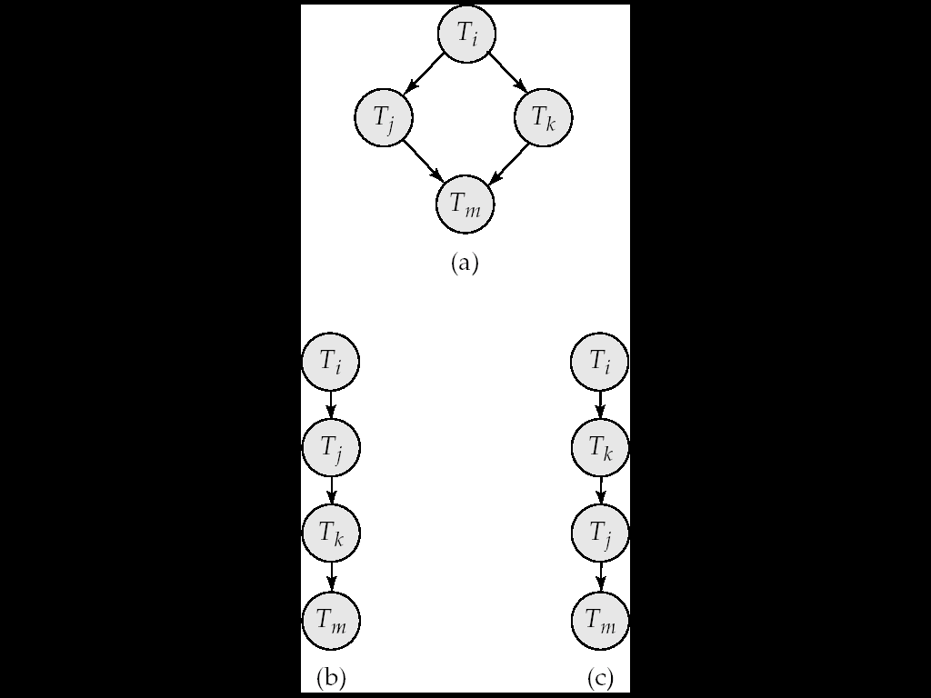

Test for View Serializability
- The precedence graph test for conflict serializability cannot be used directly to test for view serializability.
- Extension to test for view serializability has cost exponential in the size of the precedence graph.
- The problem of checking if a schedule is view serializable falls in the class of NP-complete problems.
- Thus existence of an efficient algorithm is extremely unlikely.
- However practical algorithms that just check some sufficient conditions for view serializability can still be used.

3. DISCUSS IN DETAIL THE TWO-PHASE LOCKING PROTOCOL
TWO-PHASE LOCKING PROTOCOL:
- A locking protocol that ensures conflict-serializable schedules. It works in two phases:
- Phase 1: Growing Phase: transaction may obtain locks transaction may not release locks
- Phase 2: Shrinking Phase: transaction may release locks transaction may not obtain locks
- When the first lock is released, the transaction moves from phase 1 to phase 2.
- Properties of the Two-Phase Locking Protocol. Ensures serializability It can be shown that the transactions can be serialized in the order of their lock points (i.e. the point where a transaction acquired its final lock).
- Does not ensure freedom from deadlocks. Cascading roll-back is possible. Modifications of the two-phase locking protocol
Strict two-phase locking
- A transaction must hold all its exclusive locks till it commits/aborts
- Avoids cascading roll-back
Rigorous two-phase locking
- All locks are held till commit/abort. Transactions can be serialized in the order in which they commit.
- Refine the two-phase locking protocol with lock conversions
Phase 1:Acquire a lock-S on item can acquire a lock-X on item can convert a lock-S to a lock-X (upgrade)
Phase 2: can release a lock-S,can release a lock-X,can convert a lock-X to a lock-S (downgrade)
- Ensures serializability; but still relies on the programmer to insert the various locking instructions.
- Strict and rigorous two-phase locking (with lock conversions) are used extensively in DBMS.
- Automatic Acquisition of Locks:
- A transaction Ti issues the standard read/write instruction without explicit locking calls (by the programmer).
- The operation read(D) is processed as:
if Ti has a lock on D then
read(D)
else
if necessary wait until no other transaction has a lock-X on D;
grant Ti a lock-S on D;
read(D);
end
- write(D) is processed as:
if Ti has a lock-X on D then
write(D)
else
- if necessary wait until no other transaction has any lock on D;
if Ti has a lock-S on D then
upgrade lock on D to lock-X
else
grant Ti a lock-X on D;
end
write(D);
end
All locks are released after commit or abort
Implementation of Locking:
- A lock manager can be implemented as a separate process to which transactions send lock and unlock requests.
- The lock manager replies to a lock request by sending a lock grant message (or a message asking the transaction to roll back, in case of a deadlock).
- The requesting transaction waits until its request is answered.
- The lock manager maintains a data structure called a lock table to record granted locks and pending requests.
Lock table:
- Implemented as in-memory hash table indexed on the data item being locked. Black rectangles indicate granted locks.
- White rectangles indicate waiting requests. Records also the type of lock granted/requested.
- Processing of requests:
  - New request is added to the end of the queue of requests for the data item, and granted if it is compatible with all earlier locks.
  - Unlock requests result in the request being deleted, and later requests are checked to see if they can now be granted.
  - If transaction aborts, all waiting or grantedrequests of the transaction are deleted. Index on transaction to implement this efficiently.

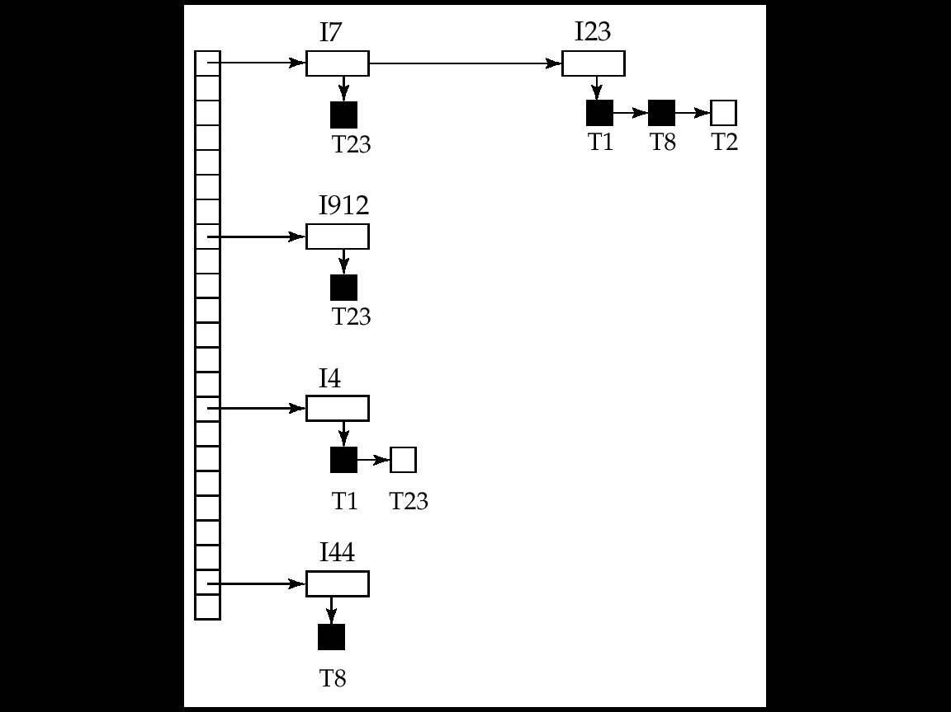

- DISCUSS THE DEADLOCK HANDLING IN DETAIL. (APR 2011) (MAY 2009)

DEADLOCK HANDLING:
- A System is in a deadlock state if there exists a set of transactions such that every transaction in the set is waiting for another transaction in the set.
- More prescisely there exists a set of waiting transaction{To,T1…..Tn} such that To is waiting for a data item that T1 holds and T1 is waiting for a data item thatT2 holds and Tn-1 is waiting for a data item that Tn holds and Tn is waiting for a data item that To holds.
- There are two principal method for dealing with the deadlock problem.
1. Deadlock Prevention
2. Deadlock detection and deadlock recovery.
- Consider the following two transactions:
T₁: write (X) T₂: write(Y)
write(Y) write(X)
- Schedule with deadlock
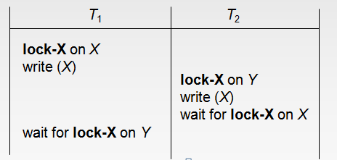
DEADLOCK PREVENTION:
- There are two approaches to deadlock prevention.One approach ensures that no cyclic waits can occurby ordering the request for locks or requiring all locks to be acquired together.
- The other approach is closer to deadlock recovery and performs transaction rollback instead of waiting for a lock whenever the wait could potentially result in a deadlock.
- The first approach requires that each transaction locks all its data items before it begins exection.There are two main disadvantages to this protocol.
- It is often hard to predict before the transaction begins what data items need to be locked.
- Data-items utilization may be very low, since many of the data items may be locked but unused for a long time.
- The second approach fo preventing deadlocks is to use preemption and transaction rollbacks.
- In preemption when a transaction T2 requests a lock that transaction T1 holds the lock granted to T1 may be preempted by rolling back of T1 and granting of the lock to T2.
- Two different deadlock prevention schemes using timestamps have been proposed.
- The wait-die scheme is a nonpreemptive technique. When transaction Ti request a data item currently held byTj, Ti is allowed to wait only if it has timestamp smaller than that of Tj and otherwise Ti is rolled.
- The wound-wait scheme is a preemptive technique. It is a counterpart to the wait-die scheme. when transaction Ti request a data item currently held by Tj, Ti is allowed to wait only if it has a timestamp larger than that of Tj.
- Whenever the system rolls back transaction it is important to ensure that there is no starvation and no transaction gets rolled back repeatedly and is never allowed to make progress.
TIMEOUT-BASED SCHEMES:
- Another simple approach to deadlock handling is based on lock timeouts.In this approach a transaction that has requested a lock waits for at specified amount of time.
- The timeout scheme is particularly easy to implement and works well if transaction are short and if long waits are likely to be due to deadlocks.
- Too long a wait result in unnecessary delays once a deadlock has occurred.
- Too short a wait result in transaction rollback even when there is no deadlock leading to wasted resources.starvation is also a possibility with scheme.The timeout-based scheme has limited applicability.

DEADLOCK DETECTION AND RECOVERY:
- When a deadlock is detected, the system must recover from the deadlock. The most common solution is to roll back one or more transactions to break the deadlock. Three actions are required:
- Selection of a victim: Select that transaction(s) to roll back that will incur minimum cost.
- Rollback: Determine how far to roll back transaction. Total rollback: Abort the transaction and then restart it. More effective to roll back transaction only as far as necessary to break deadlock.
- Check Starvation: happens if same transaction is always chosen as victim. Include the number of rollbacks in the cost factor to avoid starvation
DEADLOCK DETECTION:
- Deadlock can be described precisely in terms of a directed graph called a wait for graph.This graph consists of a pair G=(V,E),where V is a set of vertices and E is a set of edges.The set of vertices consists of all the transaction in the system.
- Each element in the set E of edges is an ordered pair Ti->Tj.IfTi->Tjis in E,then there is a directed edge from transactionTi to Tj implying that transactionti is waiting for transaction Tj to release a data itemthat it needs.To illustrate this consepts consider the wait for graph.
Transaction T25 is waiting for transaction T26 and T27.
Transaction T27 is waiting for transaction T26.
Transaction T26 is waiting for transaction T28.
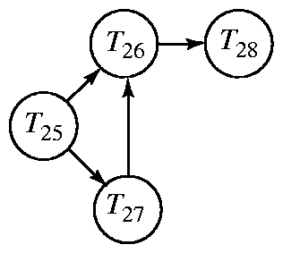
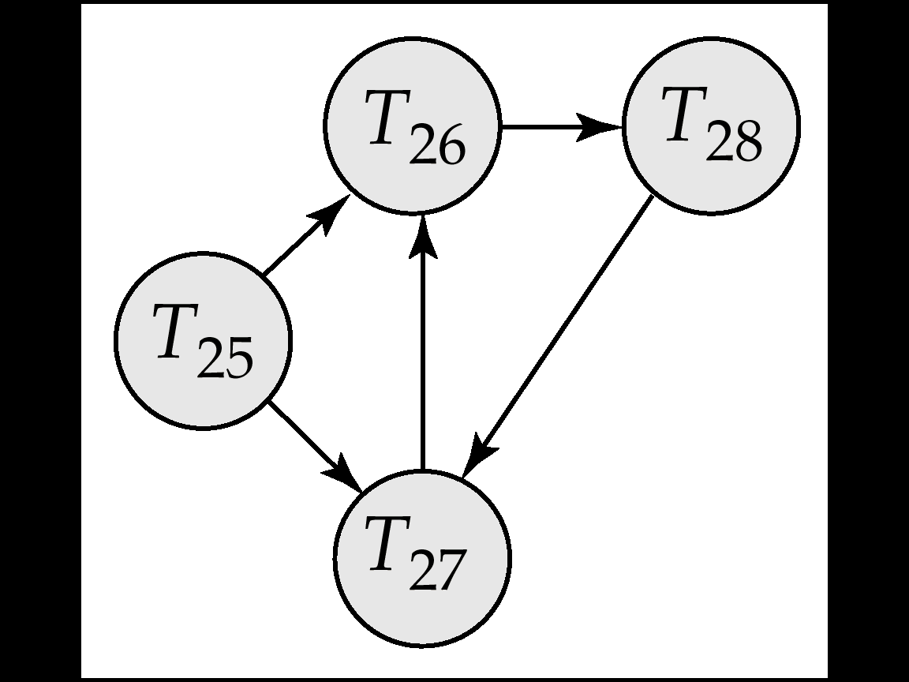

RECOVERY FROM DEADLOCK:
- When a detection algorithm determines that a deadlock exists the system must recover from the deadlock.The most common solution is to roll back one or more transaction to break the deadlock.
- Selection of a Victim: Given a set of deadlocked transactions, we must determine which transaction to roll back to break the deadlock.We should roll back those transactions that will incur the minimum cost.
- Rollback: Once we have decided that a particular transaction must be rolled back we must determine how far this transaction should be rolled back.The simplest solution is a total rollback.However it is more effective to roll back the transaction only as far as necessary to break the deadlock.Such partial rollback requires the system to maintain additional information about the state of all the running transactions.
- In a system where the selection of victims is based primarly no cost factors.It may happen that the same transaction is always picked as a victim.As a result this transaction never completes its designated task thus there is a starvation.The most common solution is to include the number of rollback is in the cost factors.
5. WRITE NOTE ON: A. TIMESTAMP BASED PROTOCOL (MAY 2012) (Nov 2015)
B. MULTIPLE GRANULARITY
- THE TIMESTAMP-ORDERING PROTOCOL:
- The timestamp-ordering protocol ensures that any conflicting read and write operations are executed in timestamp order.This protocols operates as follows:
- Suppose that transaction Ti issues read(Q).
- If TS(Ti)<W-timestamp(Q), then Ti needs to read a value of Q that was already overwritten. hence the read operation is rejected and Ti is rolled back.
- If TS(Ti)=>W-timestamp(Q) then the read operation is executed and R-timestamp(Q) is set to the maximum of R-timestamp(Q) and TS(Ti).
- Suppose that transaction Ti issues write(Q).
- If Ts(Ti)<R-timestamp(Q) the the value of Q thatTi is producing was needed previously and the system assumed that the value would never be produced.
- If TS(Ti)<W-timestamp(Q), then Ti is attempting to write an obsolete value of Q.hence the system rejects this write operation and rolls Ti back.
- Otherwise the system executes the write operation and sets W-timestamp(Q)to TS(Ti).
- The protocol can generate schedules that are not recoverable.However it can be extended to make the schedules recoverable in one several ways
- Recoverability and cascadelesssness can be ensured by performing all writes together at the end of the transaction.
- Recoverability and cascadelessness can also be guaranteed by using a limited form of locking whereby reads of uncommitted items are postponed until the transaction the updated the item commits.
- Recoverability alone can be ensured by tracking uncommitted writes and allowing a transaction Ti to commit only after the commit of any transaction that wrote a value that Ti read.
- Example: The following schedule is possible under the timestamp ordering protocol. Since TS(T14) < TS(T15), the schedule must be conflict equivalent to schedule <T14,T15>
read(B)
read(B)
B := B – 50
write(B)
read(A)
read(A)
display(A+B)
A := A + 50
write(A)
display(A+B)
T14 T15
Correctness of Timestamp-Ordering Protocol
- The timestamp-ordering protocol guarantees serializability since all the arcs in the precedence graph are of the form:
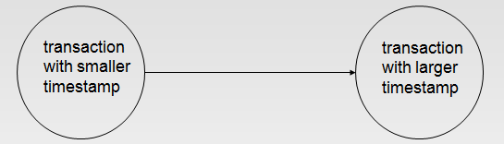
- Thus, there will be no cycles in the precedence graph
- Timestamp protocol ensures freedom from deadlock as no transaction ever waits.
- But the schedule may not be cascade-free, and may not even be recoverable.
Thomas’ Write rule:
  - Let us consider schedule 4 and apply the timestamp ordering protocol.Since T16 starts before T17 we shall assume that TS(T16)<TS(T17).
  - The read(Q) operation of T16 succeeds as does the write (Q) operation,we find that TS(T16)<W-timestamp(Q),since W-timestamp(Q)=TS(T17).
  - Thus the write (Q) by T16 is rejected and transaction T16 must be rolled back.
  - Although the rollback of T16 is required by the timestamp ordering protocol it is unnecessary.Since T17 has already written Q,the value that T16 is attempting to write is one that will never need to be read.
  - Any transaction Ti with TS(Ti)<TS(T17) that attempts a read(Q) will be rolled back.Since TS(Ti)<W-timestamp(Q).
The modification to the timestamp-ordering protocol called Thomas write rule is this.Suppose that transaction Ti issues write(Q).
    - If TS(Ti)<R-timestamp(Q),then the value of Q that Ti is producing was previously needed and it had been assumed that the value would never be produced.Hence the system rejects the write operation and rolls Ti back.
    - If TS(Ti)<W-timestamp(Q) then Ti is attempting to write an obsolute value of Q.Hence the write operation can be ignored.
    - Otherwise the system executes the write operation and sets
W-timestamp(Q) to TS(Ti).
Under Thomas’ write rule the write(Q) operation of T16 would be ign ored.The result is a schedule that is view equivalent to the serial schedule<T16,T17>.
- MULTIPLE GRANULARITY
- Instead of locks on individual data items, sometimes it is advantageous to group several data items and to treat them as one individual synchronization unit (e.g. if a transaction accesses the entire DB).
- Define a hierarchy of data granularities of different size, where the small granularities are nested within larger ones.
- Can be represented graphically as a tree When a transaction locks a node in the tree explicitly, it implicitly locks all the node's descendents in the same mode.
- Example: Graphical representation of a hierarchy of Granularities The highest level is the entire database.The levels below are of type area, file and record in that order.
- Granularity of locking (= level in tree where locking is done): fine granularity (lower in tree): high concurrency, high locking overhead. coarse granularity (higher in tree): low locking overhead, low concurrency
Multiversion Protocols:
- Concurrency control protocols studied thus far ensure serializability by either delaying an operation or aborting the transaction.
- Multiversion schemes keep old versions of data items to increase concurrency.
- Each successful write(Q) creates a new version of Q.Timestamps are used to label versions.When a read(Q) operation is issued, select an appropriate version of Q based on the timestamp of the transaction. reads never have to wait as an appropriate version is available.
- Two types of multiversion protocols
- Multiversion timestamp ordering
- Multiversion two-phase locking

Multiversion Timestamp Ordering:
- Each data item Q has a sequence of versions<Q1,Q2,....,Qm>. Each version Qk contains 3 data fields:
- Content – the value of version Qk.
- W-timestamp(Qk) – timestamp of the transaction that created(wrote) version Qk
- R-timestamp(Qk) – largest timestamp of transaction that successfully read version Qk
- When a transaction Ti creates a new version Qk of Q,the W-timestamp and R-timestamp of Qk are initialized to TS(Ti).
- R-timestamp of Qk is updated whenever a transaction Tj reads Qk, and TS(Tj) > R-timestamp(Qk).
The following multiversion timestamp-ordering protocol ensures serializability.
- If transaction Ti issues a read(Q), then the value returned is the content of version Qk, which is the version of Q with the largest write timestamp less than or equal to TS(Ti)
- If transaction Ti issues a write(Q):
- If TS(Ti) < R-timestamp(Qk), then transaction Ti is rolled back.
- Otherwise, if TS(Ti) = W-timestamp(Qk), the contents of Qk are overwritten.
- Otherwise a new version of Q is created.
Properties of the multiversion timestamp-ordering protocol reads always succeed and never have to wait A transaction reads the most recent version that comes before it in time.In a typical DBMS reading is a more frequent operation than writing, hence this advantage might be significant.

6.EXPLAIN THE LOG-BASED RECOVERY SCHEME IN DETAIL. ( MAY 2012) (NOV 2009)(Nov 2015)
LOG BASED RECOVERY
- A log is kept on stable storage.
- The log is a sequence of log records, and maintains a record of update activities on the database.
- When transaction Ti starts, it registers itself by writing a<Ti start>log record
- Before Ti executes write(X), a log record <Ti, X, V1, V2> is written,
- where V1 is the value of X before the write, and V2 is the value to be written to x.
- Log record notes that Ti has performed a write on data item Xj Xj had value V1 before the write, and will have value V2 after the write.
- When Ti finishes it last statement, the log record <Ti commit> is written to .x
- We assume for now that log records are written directly to stable storage (that is, they are not buffered)
- Two approaches using logs
- Deferred database modification
- Immediate database modification

Deferred Database Modification
- The deferred database modification scheme records all modifications to the log, but defers all the writes to after partial commit.
- Assume that transactions execute serially
- Transaction starts by writing <Ti start> record to log.
- A write(X) operation results in a log record <Ti, X, V> being written, where V is the new value for X.
- Note: old value is not needed for this scheme.
    - The write is not performed on X at this time, but is deferred. When Ti partially commits, <Ti commit> is written to the log .
    - Finally, the log records are read and used to actually execute the previously deferred writes.
    - During recovery after a crash, a transaction needs to be redone if and only if both <Ti start> and<Ti commit> are there in the log.
    - Redoing a transaction Ti ( redoTi) sets the value of all data items updated by the transaction to the new values.
    - Crashes can occur while the transaction is executing the original updates, or while recovery action is being taken

- example : transactions T0 and T1 (T0 executes before T1):
T0 : read (A)
T1 : read (C)
A: - A - 50 C:- C- 100
Write (A) write (C)
read (B)
B:- B + 50
write (B)
- Below we show the log as it appears at three instances of time.
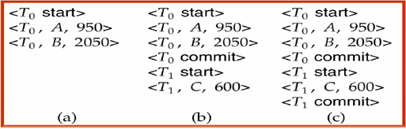
- If log on stable storage at time of crash is as in case:
- No redo actions need to be taken
- redo(T0) must be performed since <T0 commit> is present
- redo(T0) must be performed followed by redo(T1) since
- <T0 commit> and <Ti commit> are present
Immediate Database Modification
- The immediate database modification scheme allows database updates of an uncommitted transaction to be made asthe writes are issued.
- since undoing may be needed, update logs must have both old value and new value
- Update log record must be written before database item is written.
- We assume that the log record is output directly to stable storage
- Can be extended to postpone log record output, so long as prior to execution of an output(B) operation for a data block B, all log records corresponding to items B must be flushed to stable storage.
    - Output of updated blocks can take place at any time before or after transaction commit.
    - Order in which blocks are output can be different from the order in which they are written.
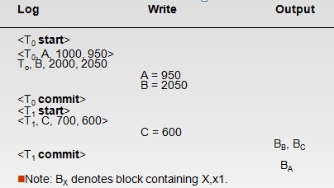
- Recovery procedure has two operations instead of one:
- undo(Ti) restores the value of all data items updated by Ti to their old values, going backwards from the last log record for Ti
- redo(Ti) sets the value of all data items updated by Ti to the new values, going forward from the first log record for Ti.Both operations must be idempotent That is, even if the operation is executed multiple times the effect is the same as if it is executed once
- Needed since operations may get re-executed during recover When recovering after failure:
- Transaction Ti needs to be undone if the log contains the record
- <Ti start>, but does not contain the record <Ti commit>.
- Transaction Ti needs to be redone if the log contains both the record
- <Ti start> and the record <Ti commit>.

- Undo operations are performed first, then redo operations.
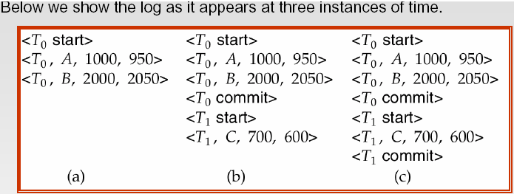
- Recovery actions in each case above are:
- undo (T0): B is restored to 2000 and A to 1000.
- undo (T1) and redo (T0): C is restored to 700, and then A and B are set to 950 and 2050 respectively.
- redo (T0) and redo (T1): A and B are set to 950 and 2050 respectively. Then C is set to 600

7. WRITE NOTE ON: A. CHECKPOINTS B. SHADOW PAGING (MAY 2009)(Apr 2016)
- GRAPH BASED PROTOCOL (MAY 2009)
A. Checkpoints:
- When a system failure occurs, we must consult the log to determine those transactions that need to be redone and those that need to be undone. We need to search the entire log to determine this information.
- There are two major difficulties with this approach:
- The search process is time consuming.
- Most of the transaction that, according to our algorithm, need to be redone have already written their updates into the database.
- To reduce these types of difficulties, we introduce checkpoints.During execution, the system maintains the log, the system periodically performs checkpoints, which require the following
- sequence of action to take place:
- Output onto stable storage all log records currently residing in main memory.
- Output to the disk all modified buffer blocks.
- Output onto stable storage a log record <checkpoint>.
- Transaction are not allowed to perform any update actions, such as writing to a buffer block or writing a log record, while a checkpoint is in progress.
- Consider a transaction T_{i} that committed prior to the checkpoint.
- For such a transaction, the <T_{i} commit> record appears in the log before the <checkpoint> record. Any database modifications made by T_{i} must been written to the database either prior o the checkpoint or as part of the checkpoint itself.
B. SHADOW PAGING
- Shadow paging is an alternative to log-based recovery
- It is useful if transactions execute serially
- Requires fewer disk access, compare to log based methods the database is partitioned into some number of fixed-length blocks, which are referred to as pages.
- Page Table is used locate the ith page of database for given i.

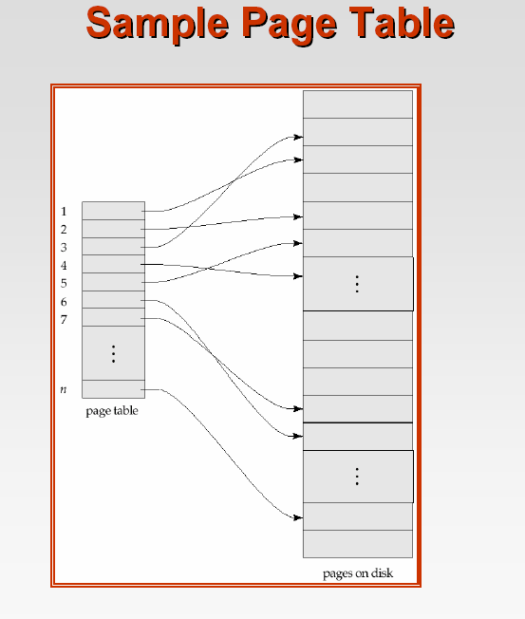
Sample Page Table

- It maintain two page tables during the lifetime of a transaction
  - current page table and
  - shadow page table
- Store the shadow page table in nonvolatile storage, such that state of the database prior to transaction execution may be recovered.
- Shadow page table is never modified during execution. To start with, both the page tables are identical. Only current page table is used for data item accesses during execution of the transaction.
Whenever any page is about to be written for the first time.
- A copy of this page is made onto an unused page.
- The current page table is then made to point to the copy.
- The update is performed on the copy.

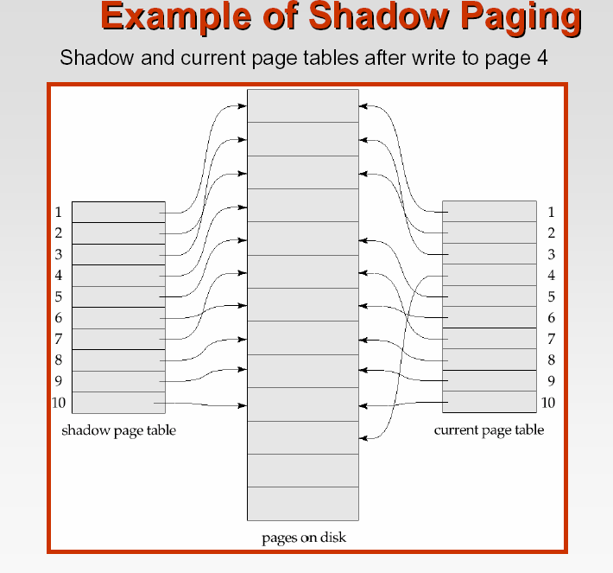
- To commit a transaction
- Flush all modified pages in main memory to disk
- Output current page table to disk
- Make the current page table the new shadow page table, as follows:
- keep a pointer to the shadow page table at a fixed (known) location on disk.
- To make the current page table the new shadow page table, simply update the pointer to point to current page table on disk
- Once pointer to shadow page table has been written, transaction is committed.
- No recovery is needed after a crash — new transactions can start right away, using the shadow page table.
- Pages not pointed to from current/shadow page table should be freed (garbage collected).
- Advantages of shadow-paging over log-based schemes
- no overhead of writing log records
- recovery is trivial
- Disadvantages:
- Copying the entire page table is very expensive
- Can be reduced by using a page table structured like a B+-tree
- No need to copy entire tree, only need to copy paths in the tree that lead to updated leaf nodes
- Commit overhead is high even with above extension
- Need to flush every updated page, and page table
- Data gets fragmented (related pages get separated on disk)
- After every transaction completion, the database pages containing old versions of modified data need to be garbage collected
- Easier to extend log based schemes
C.GRAPH-BASED PROTOCOLS
- Graph-based protocols are an alternative to two-phase locking
- Impose a partial ordering → on the set D = {d₁, d₂ ,..., d_{h}} of all data items.
If d_{i} → d_{j} then any transaction accessing both d_{i} and d_{j} must access d_{i} before accessing d_{j}.
Implies that the set D may now be viewed as a directed acyclic graph, called a database graph.
The tree-protocol is a simple kind of graph protocol.
Tree Protocol
A simple kind of graph based protocol which works as follows:
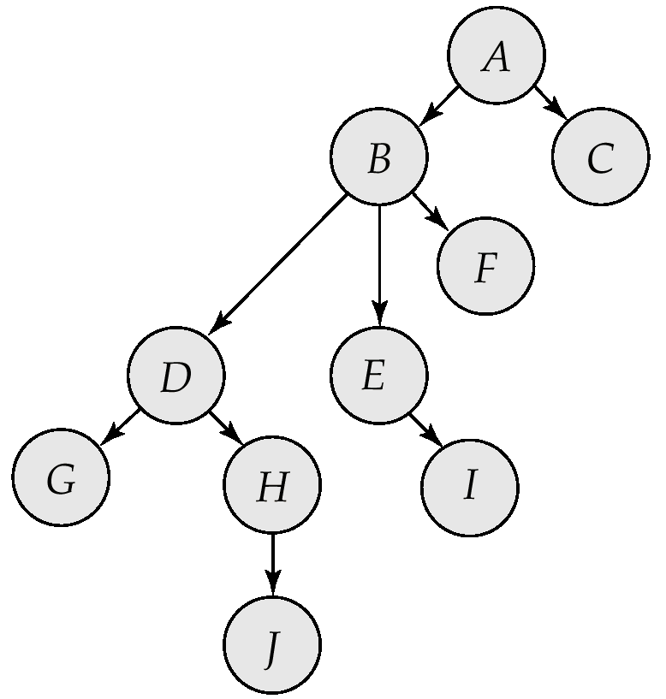
Only exclusive locks are allowed.
The first lock by T_{i} may be on any data item. Subsequently, a data Q can be locked by T_{i} only if the parent of Q is currently locked by T_{i}.
Data items may be unlocked at any time.
A data item that has been locked and unlocked by T_{i} cannot subsequently be relocked by T_{i}
The tree protocol ensures conflict serializability as well as freedom from deadlock.
Unlocking may occur earlier in the tree-locking protocol than in the two-phase locking protocol.
shorter waiting times, and increase in concurrency
protocol is deadlock-free, no rollbacks are required
Drawbacks
Protocol does not guarantee recoverability or cascade freedom
Need to introduce commit dependencies to ensure recoverability
Transactions may have to lock data items that they do not access.
increased locking overhead, and additional waiting time
potential decrease in concurrency

